**ASSIGNMENT 3**

**Cloud object storage and Watson assistant**

1. **Create a Bucket in IBM object storage**

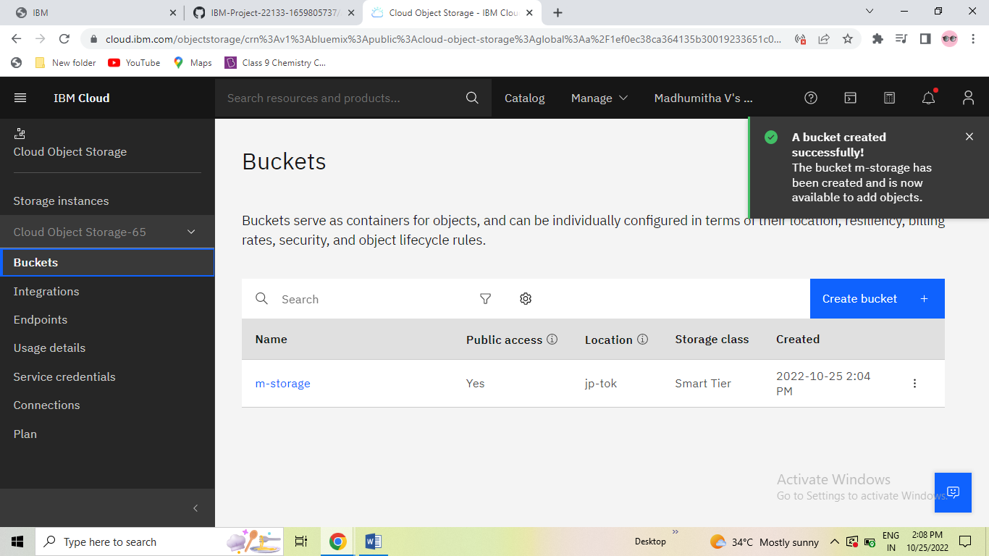

1. **Upload an 5 images to ibm object storage and make it public. Write html code to displaying all the 5 images.**

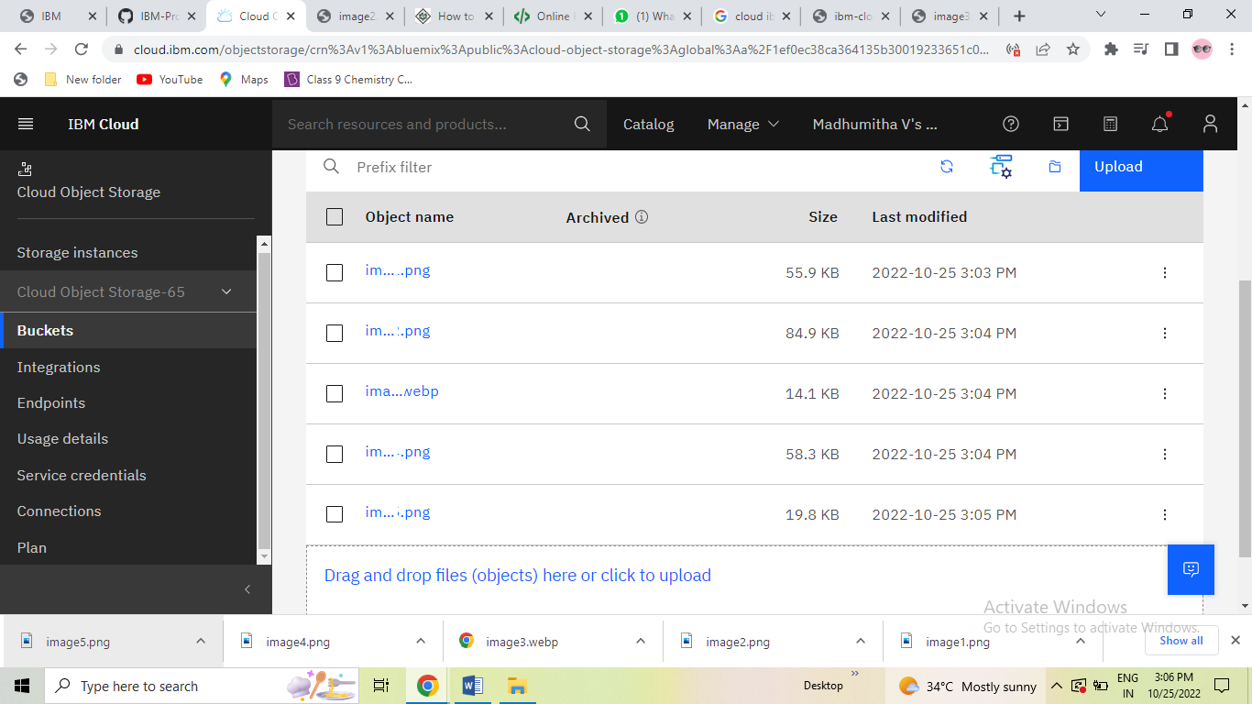

1. **Upload a css page to the object storage and use the same page in your html code.**

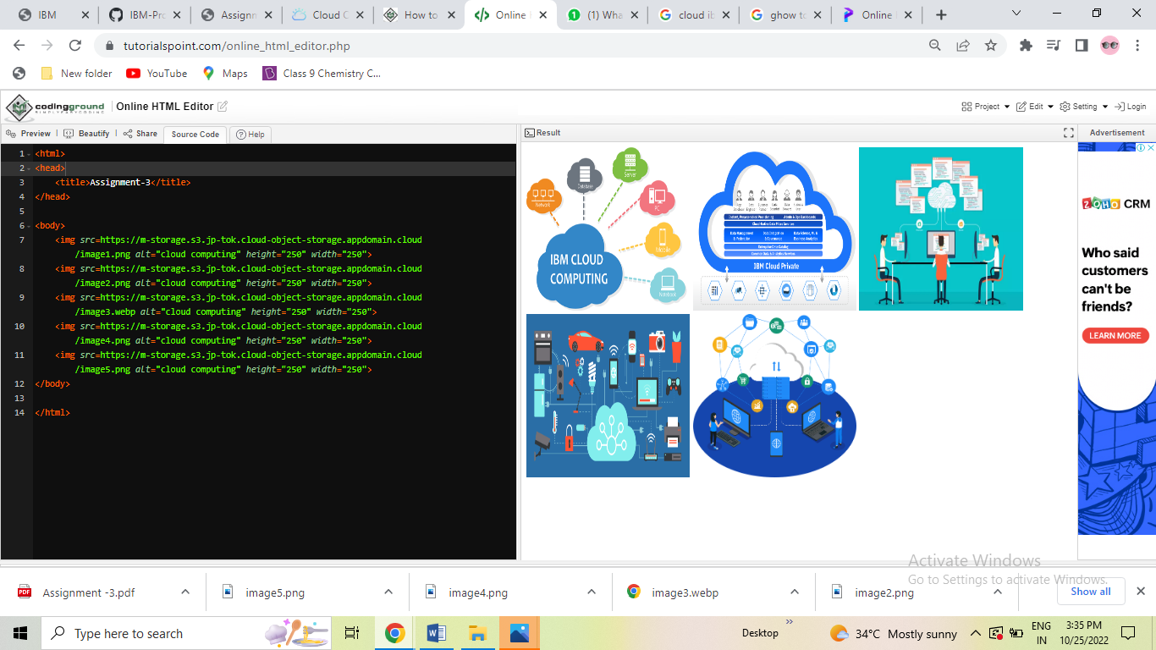

1. **Design a Chabot using IBM Watson assistant for hospital. Ex: User come the query to know the braches for that hospital in your city.**

**URL : https://web-chat.global.assistant.watson.appdomain.cloud/preview.html?backgroundImageURL=https%3A%2F%2Fus-south.assistant.watson.cloud.ibm.com%2Fpublic%2Fimages%2Fupx-bc8f9fa6-aa1c-4e2d-bab8-9e8e6e0c6bde%3A%3A194f0ce6-4b4f-429f-a40f-094598a7c9ab&integrationID=28f1c822-f9ca-4451-9c28-63aafc6c2cc8&region=us-south&serviceInstanceID=bc8f9fa6-aa1c-4e2d-bab8-9e8e6e0c6bde**

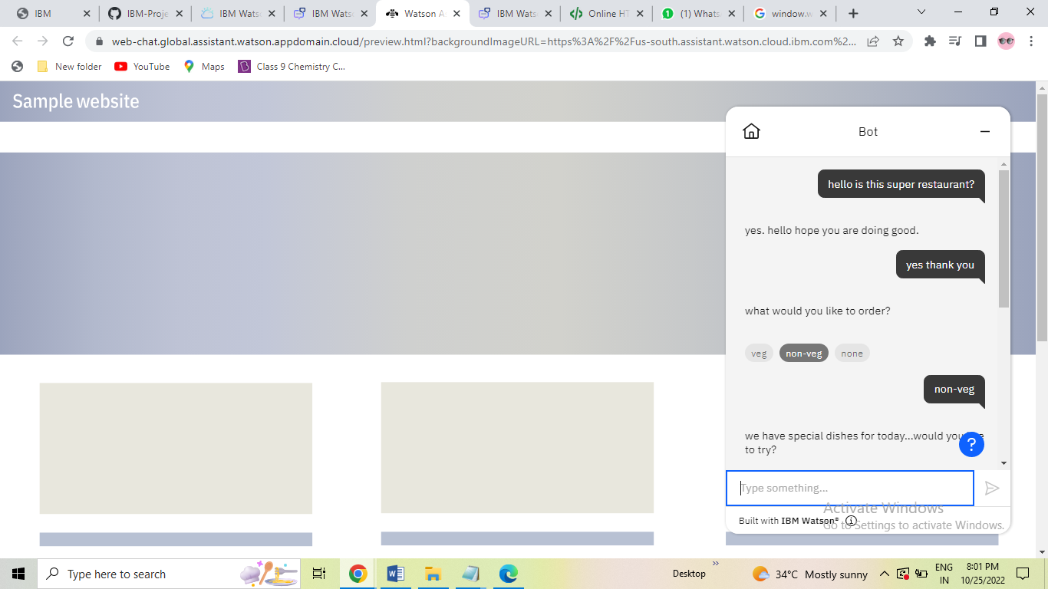

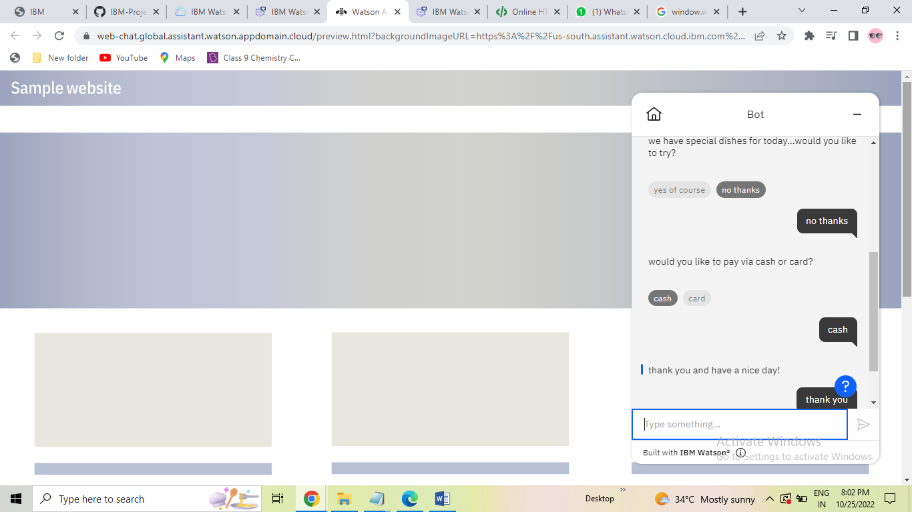

1. **Create Watson assistant service with 10 steps and use 3 conditions in it. Load that script in html page**

<html>

<head>

<title>Assignment-3</title>

</head><script>

window.watsonAssistantChatOptions = {

integrationID: "b597896b-c012-4b27-b279-4e03e2bc50bc", // The ID of this integration.

region: "us-south", // The region your integration is hosted in.

serviceInstanceID: "bc8f9fa6-aa1c-4e2d-bab8-9e8e6e0c6bde", // The ID of your service instance.

onLoad: function(instance) { instance.render(); }

};

setTimeout(function(){

const t=document.createElement('script');

t.src="https://web-chat.global.assistant.watson.appdomain.cloud/versions/" + (window.watsonAssistantChatOptions.clientVersion || 'latest') + "/WatsonAssistantChatEntry.js";

document.head.appendChild(t);

});

</script>

<link rel="stylesheet" href="https://m-storage.s3.jp-tok.cloud-object-storage.appdomain.cloud/imagecode.htm">

<body>

<img src=https://m-storage.s3.jp-tok.cloud-object-storage.appdomain.cloud/image1.png alt="cloud computing" height="250" width="250">

<img src=https://m-storage.s3.jp-tok.cloud-object-storage.appdomain.cloud/image2.png alt="cloud computing" height="250" width="250">

<img src=https://m-storage.s3.jp-tok.cloud-object-storage.appdomain.cloud/image3.webp alt="cloud computing" height="250" width="250">

<img src=https://m-storage.s3.jp-tok.cloud-object-storage.appdomain.cloud/image4.png alt="cloud computing" height="250" width="250">

<img src=https://m-storage.s3.jp-tok.cloud-object-storage.appdomain.cloud/image5.png alt="cloud computing" height="250" width="250">

</body>

</html>

